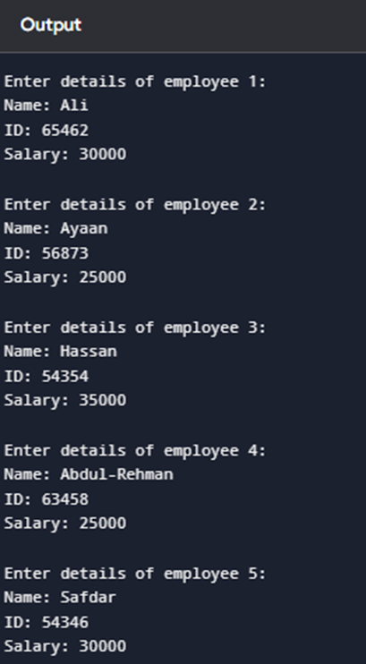
#include <iostream>
using namespace std;

struct Employee {
string name;
int id;
float salary;
};

int main() {
Employee emp[5];

// Input data for 5 employees
for (int i = 0; i < 5; i++) {
cout << "\nEnter details of employee " << i + 1 << ":\n";

cout << "Name: ";
cin.ignore(); // clear previous input
getline(cin, emp[i].name);

cout << "ID: ";
cin >> emp[i].id;

cout << "Salary: ";
cin >> emp[i].salary;
}

// Display data
cout << "\n\n--- Employee Information ---\n";
for (int i = 0; i < 5; i++) {
cout << "\nEmployee " << i + 1 << ":\n";
cout << "Name: " << emp[i].name << endl;
cout << "ID: " << emp[i].id << endl;
cout << "Salary: " << emp[i].salary << endl;
}
return 0;
}

